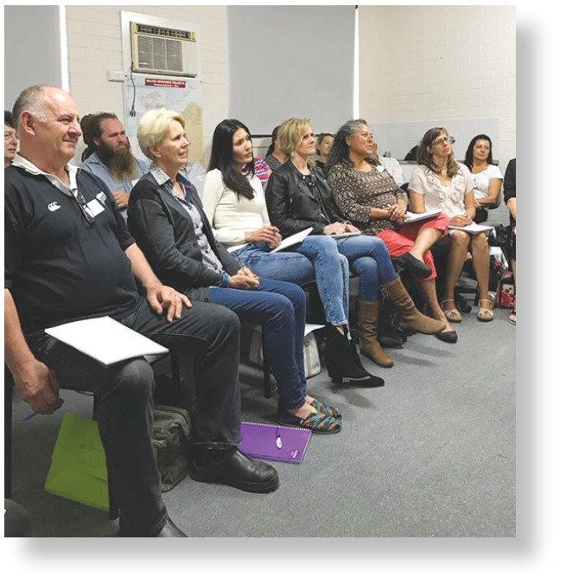
In this Pack you will find…
Course summary/s (including Fees)
Hypnosis/Hypnotherapy/Mesmerism Information
Upcoming course Dates are all at www.rickcollingwoodhypnosis.com
Certificate of Clinical Hypnotherapy Application Form
Diploma of Clinical Hypnotherapy Application Form
Checklists

Introduction…
Welcome to the Global Hypnosis Academy and thanks for your interest in our training. We will teach you how to induce all styles of hypnosis in a practical sense. For hypnotherapy to be effective, hypnotherapist needs effective practical hypnosis skills and that is what we will teach you. We not only train our students how to induce real hypnosis in a practical sense and importantly how and what to use it for therapeutically. The hypnotist is already inside of you, and we will help you to bring it out.
You’ll learn how to induce hypnosis in many various ways and how to apply the therapeutic aspects and the practical uses of hypnosis as hypnotherapy. You can be assured that you’ll learn more than just a few relaxation techniques. In a nutshell, you’ll get the finest hypnosis/hypnotherapy training available in Australia, from Australia’s longest established hypnosis training institution.

Diploma of Clinical Hypnotherapy

We train the methods of Traditional and Ericksonian Hypnosis, Mesmerism, and all its uses, plus the truth about NLP. You won’t be bogged down with theory. Instead, you’ll learn techniques that will enable you to do genuine and effective hypnosis from one of the world’s foremost hypnosis trainers. You will learn rapid and instant inductions, Mesmerism, and the almost forgotten art of ‘Hypnotic Fascination’.
Our training is suitable for Counsellors, Psychologists, for practicing hypnotherapists who want to improve their skills, for other allied health practitioners who want to gain hypnotherapy skills, any responsible adult seeking to become a professional clinical hypnotherapist, and people looking for self- improvement and a better understanding of the human mind and human behaviour.

We have the highest Google Review ratings of any Hypnosis training organisation in Australia for a good reason.

We are Australia’s Longest Established
Hypnosis Training Institution

Styles and Types of Hypnosis
During the past 33 years, the Global Hypnosis Academy™ has trained more than 5000 students nationally and internationally; many of them became very successful professional hypnotherapists. What the academy brings to the training arena are real hypnosis techniques that work on a physical, mental, emotional, and spiritual level – techniques that have taken Rick to the top of the profession. Nothing is held back and there are no up sells to apparent master or secret techniques. Rick will teach you all that he knows and how to apply it to your own life and the lives of your clients. You will get hands on training, and you’ll learn your theory from the extensive training manuals provided and in the academy’s student online training and resource centre.
During the training you will be inducing trance under supervision from the first day and we will ensure that you get it right. After that, mastering what we teach to you will be in direct proportion to your passion for hypnosis and the practice you put into what you learn.
After the completion of your initial training, you will have ample opportunity for more advanced training, regular monthly and specialty training, and permanent access into the online training and resource centre at www.rickcollingwoodhypnosis.com

Some of the common styles of hypnosis and hypnotherapy are…
Ericksonian Hypnosis: This is a therapeutic model of hypnosis created by the American Psychiatrist Milton Erickson. Ericksonian Hypnosis is most effectively utilised by a skilled and experienced Psychotherapist and does not usually require or effect deep hypnotic trance states. After a relaxed state has been achieved by the subject, direct hypnotic suggestion is replaced by ambiguity, and metaphor is often used during the therapy sessions; which will usually be about 10 to 15 in number.
NLP or Neuro Linguistic Programming: Regardless of what persistent slick marketing efforts may try to have you believe; NLP IS NOT HYPNOSIS. It is supposedly the study of excellence, and it does have some interesting and no doubt effective strategies. NLP also offers a lot of insight into human behaviour and the mind. However, because an NLP training institute may offer NLP training under the guise of it being hypnosis that is frequently claimed by its proponents. This is amply demonstrated by the fact that after more than a decade of clinical trials and studies at respectable academic institutions; no evidence could be found to back up the many claims made about the power and effectiveness of NLP. If you are learning NLP, you are not learning hypnosis.
Traditional Hypnosis: Traditional hypnosis is direct hypnosis. It is genuine hypnosis, the type of hypnosis that despite academic opinion can make many individuals do things that are against their moral patterning or usual personality. Traditional hypnosis can be blended with Mesmerism, NLP and Ericksonian Hypnosis to create a very powerful therapeutic modality.
Mesmerism: Mesmerism is derived from the presumed father of hypnosis. The German doctor Franz Anton Mesmer (1734-1815), however it is probably more correctly described as energetic hypnosis as very few words are used to induce a mesmeric state.
Many Hypnosis Training Institutions predominantly teach theory or hypnosis hybrids such as NLP or so- called Conversational Hypnosis, or they have a significantly academic approach within their training curriculum, offering either none, or very little practical training in actual trance inductions. If you really want to see what you’ll learn, go online and see if you can find a trainer actually inducing hypnosis.

Hypnotherapy Training – What Are You Really Learning?
Our training is backed up by three decades of real-world experience, it is very thorough and ‘hands on’. You’ll learn the practicalities of Real Hypnosis. The academic content is in-depth, focusing on how to use hypnosis correctly and effectively for therapy, the historical development, various aspects and views, plus a step-by-step ‘how to’ correctly induce Hypnosis, Mesmerism and Fascination trance states for therapeutic benefit.
All training materials are supplied, and examinations and assessments are open book.
You will learn approaches to therapy and sub-modalities i.e., Hypnosis with Children and Hypnosis for Disease, Rapid Inductions, Advanced Modern and Traditional techniques are taught. Mesmerism and Hypnotic Fascination are also explained, demonstrated, and practiced during the Diploma training and even more so during the Advanced Diploma of Clinical Hypnotherapy training.
There is further support beyond the training - All students gain access to the Academies huge Online Student Training and Resource Centre filled with 100s of ‘filmed in class’ training videos, training courses from associated trainers and relevant hypnosis books. You will also get regular newsletters, association introductions, peer support, forums, old hypnosis books, and directions to insurance coverage.
There are many different styles and variations of hypnosis and trance for therapy. We will train you in all of practicalities of conducting hypnosis for hypnotherapy, with Traditional Hypnosis, Ericksonian Hypnosis, NLP and Mesmeric and Hypnotic Fascination techniques.
During your eight-days training, you will learn the correct history of hypnosis and its uses, plus gain effective practical skills for inducing the hypnotic trance state and how to correctly induce and utilise hypnosis for therapeutic purposes. You’ll experience hypnosis demonstrations, and you’ll partake in a significant amount of supervised hypnosis induction practice.
Applying the hypnotic condition to others is a practical skill and so academia alone does not and cannot make a proficient hypnotherapist.
Because most of the ‘in class’ training is practical and ‘hands on’, you’ll have the ability to induce effective hypnosis by the time you’ve completed the Diploma of Clinical Hypnotherapy, we won’t try to sell you any more or extra training.
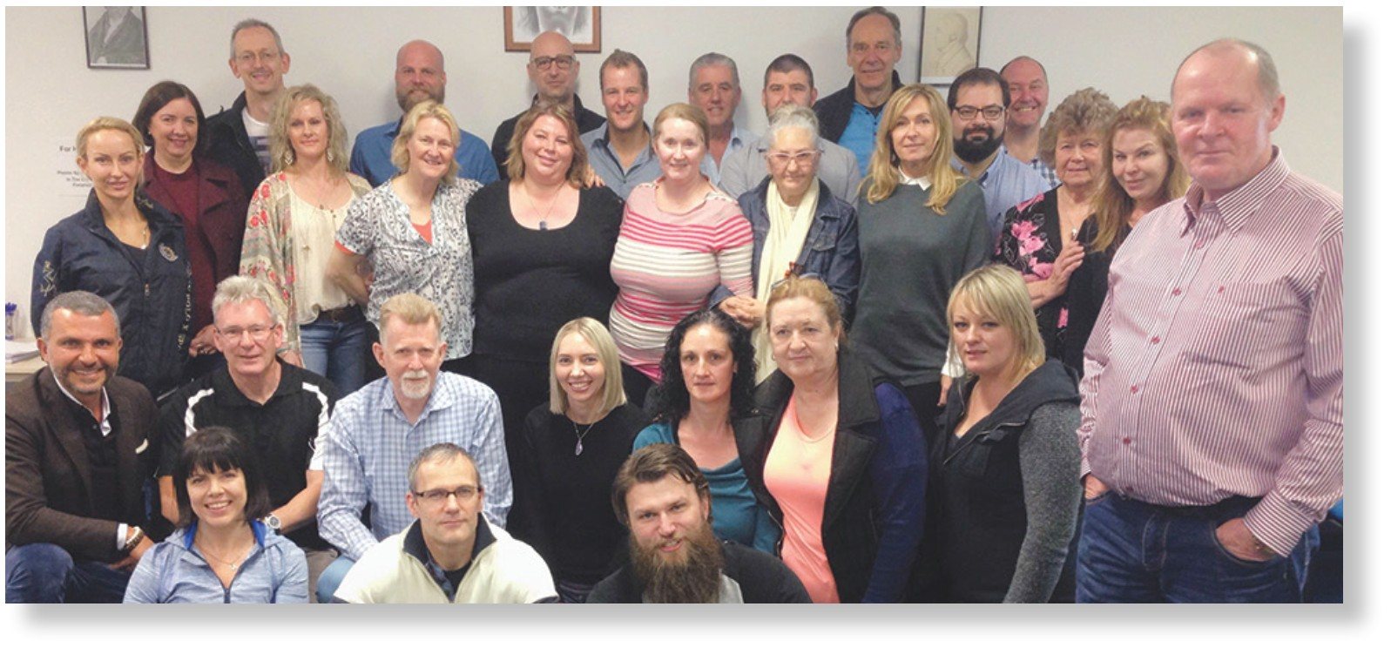

What You’ll Learn
- Hypnosis, Hypnotherapy, Hypnotic Inductions, Mesmerism, Self-Hypnosis and how to apply the techniques
- Applying all techniques of Hypnosis and Clinical Hypnotherapy;
- Building your Clinical Hypnotherapy business;
- Working legally and ethically;
- Reflecting on and improving your own professional practice;
- A one-day training in self-hypnosis and therapy practice promotion and management;
- Establishing and managing client relationships;
- You’ll learn all practical aspects of applying hypnosis
- You’ll be a competent and confident hypnotist/hypnotherapist
- You’ll be able to work with many conditions such as Quit Smoking Weight Loss Insomnia Motivation Depression Past Life Regression and many other common challenges.

What our training enables you to do?
Launch and build your own practice or enhance your present therapy skills

The Academy’s Extensive Hypnotherapy Training Curriculum Includes:
- Hands-On Practice right from the start
- Monthly Online Zoom Student Supervision by your Certified Trainer
- Interviewing Techniques and Therapy Planning to Determine the Suggestions Necessary for the client’s Best Results
- Suggestibility Testing
- Deepening
- How To Induce Hypnosis – Not Relaxation
- Many Different Inductions
- Creating Effective Post Hypnotic Suggestions
- Deepening Techniques
- Past Life Regression Techniques
- Getting Indemnity Insurance
- Gaining Hypnotherapy Association Membership
- Starting And Growing A Successful Hypnotherapy Business
- Permanent Access into The World’s Biggest Online Hypnosis Training and Resource Centre
- Begin At Your Own Pace As Soon As You Enrol

Self-Paced Training Begins Immediately Upon Registration
You will begin immediately online. Once you have registered and paid your training fees you will receive your acceptance letter, E version training manual PDFs and a password to access the academy’s on-line student training and resource centre portal, plus step- by - s t e p instructions on how to begin your self- paced, pre in class, training. You will also get access to monthly 1-hour zoom instruction sessions plus gain access to a full on-line zoom training courses plus hundreds of filmed in class video tutorials, PDF eBooks’ and much more.

How To Enrol
Before enrolment if you need any further information you can find it in the Q&As at www.rickcollingwoodhypnosis.com , or email Rick Collingwood rickcollingwoodhypnosis@gmail.com.
Fee Payment. You can make your payment online at www.rickcollingwoodhypnosis.com, or complete the credit/debit card approval form in this information pack, and then email it back to rickcollingwoodhypnosis@gmail.com. Once your payment and completed application form are received you will receive your acceptance letter, an E version curriculum of comprehensive training manuals and a password to access the online student training and resource centre portal, so your good to go at your own pace until the in class training begins. Your email address will also be added to the academy monthly student newsletter to help you stay in touch.

Past Academy Students Discounts
If you have trained with Rick Collingwood previously at any time or any location in the past, you are eligible for a significant discount for retraining. Please go to www.rickcollingwoodhypnosis.com and scroll over the courses a drop-down menu will appear and click on Past Student Refresher Training. You can either pay online or use the form in this pack

Refund Policy
Training is considered to begin upon enrolment and payment. After enrolment students may defer their in-class training for up to three years without penalty. In the rare event that the academy has to defer a training NO REFUNDS are available. If the academy cancels a training outright a full refund will be paid within 21 days of the cancellation. All students acknowledge this upon as stated on the application form upon signing the application form.

Study In Class Hypnotherapy With Us

Diploma of Clinical Hypnotherapy
To complete the Diploma of Clinical Hypnotherapy in all training locations requires online study and the attendance of eight days of practical, in class, training attendance. Fee for the eight- day Diploma of Clinical Hypnotherapy training is. Fee: $4997 or Book Your Place with $1500 deposit. There is a $500 reduction if fees are paid in full upon registration.

Diploma of Clinical Hypnotherapy – On Going Online Training

Summary
There are the PRACTICAL and the THEORETICAL components required to attain the academies Diploma of Clinical Hypnotherapy requires the successful completion of a 150 question open book examination, a full eight day in class attendance and the completion of five self-assessments and 12 (filmed live in class training) ongoing training modules are required to be viewed in the student resource centre online.
Upon successful completion an A3 size named Diploma of Clinical Hypnotherapy is awarded. To gain the Diploma of Clinical Hypnotherapy all modules must be completed in conjunction with the in-class Diploma training component.
There are also many online zoom trainings and filmed during live in-class training in the student resource centre. As soon as you register you can begin your training online.

The 12 tutorials topics on offer are:
No. 1 Mind-Body Communication with Hypnosis (physiology and disease management)
No. 2 Abreactions within Hypnosis
No. 3 Hypnosis for Pain Management
No. 4 Hypnotic Regression (present and past life)
No. 5 Script Writing and Trance Deepening
No. 6 Magnetism and Energy Shifting
No. 7 Hypnotic Transference
No. 8 Hypnosis with Children
No. 9 Conscious – Subconscious Interfacing
No. 10 Successful Induction and Subconscious Compliance
No. 11 Hypnosis for Addictions and Substance Abuse
No. 12 Ethics and Running of a Clinical Practice

Study Stream Options Pre-Requisites

Pre-Requisites
It is a requirement of the Global Hypnosis Academy that all students be of good character and have no serious previous criminal convictions.
Because all hypnosis associations in Australia require a formal Police Clearance and Senior First Aid before membership is accepted, The Australian Academy of Hypnosis does not require you to produce them. Competence in written and spoken English are required (not formal), as is psychological stability – speak to your trainer (or psychologist) for any questions.

Once You Have Registered
After registration and fee or deposit payment, all students receive an acceptance letter and all their relevant training manuals in E Book format. So, you can begin immediately at your own pace. You will also receive a password into the academy’s student training and resource centre where you can access hundreds of filmed in class training videos PDF eBooks and much more. Diploma students maintain permanent free access into the online resource centre.

You Will Have Permanent Free Access into The Vast Online Student Training and Resource Centre – So Your Training Finishes When You Want It To
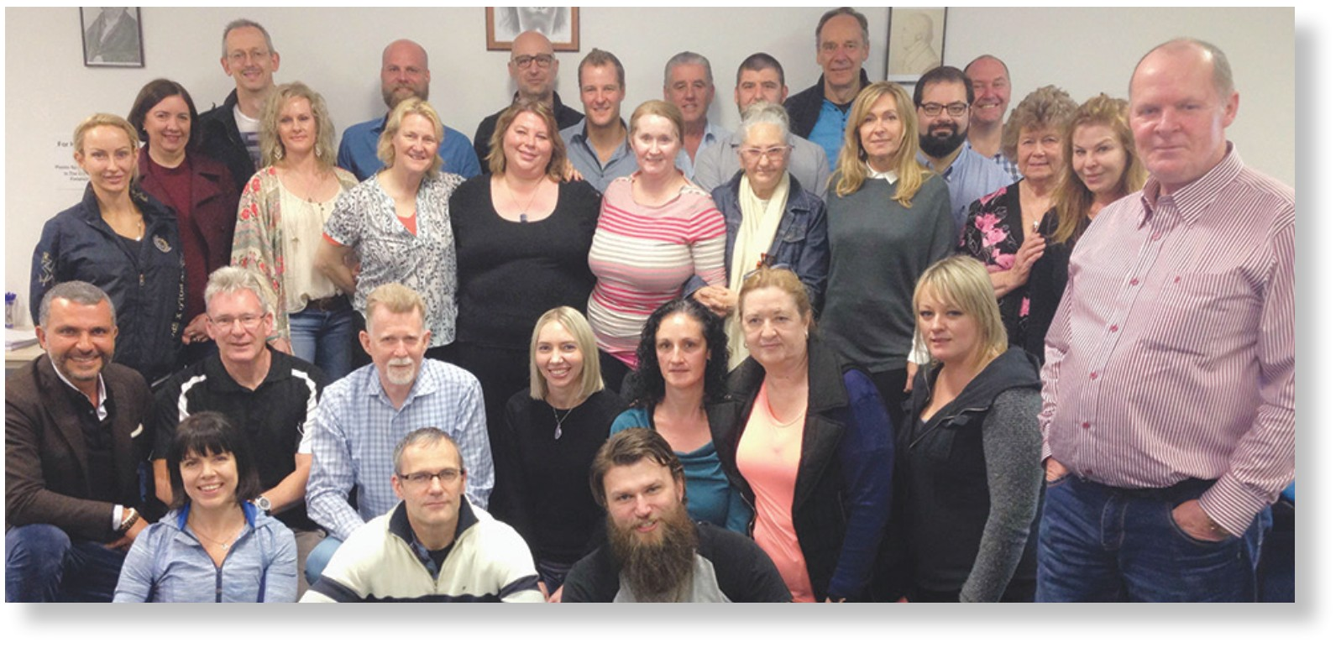

Refund Policy
The refund policy for all hypnosis trainings is as follows. After acceptance into the academy training and payment of fees there is no cooling off period and there are absolutely no refunds. Although once registered a student can defer their training to any equal training within three (3) years of payment.

Cancellation Policy
In the rare event that the academy cancels any training in its entirety a full refund will be issued within 21 days of any such cancellation.
The academy will NOT BE RESPONSIBLE and WILL NOT refund any travel or accommodation payments. Students who may be travelling to attend any trainings it is recommended that you book your airfares and/or accommodation on a changeable or refundable basis.
These conditions are absolute. All students acknowledge and agree that upon submitting an application form and being accepted for any training conducted by the Global Hypnosis Academy, that they have a full understanding of, and are in agreement with, these terms and conditions.

Deferment of Training By Student Policy
Attendance dates can be deferred to any next equivalent training for up to three years. A deferment fee of $250 applies to ANY and ALL date changes a student may request and must be paid at the time of deferment. There is no deferment fee if a student changes the date of a training they have already registered for but have not yet commenced.

About Our Trainers

Rick Collingwood – Founder
Rick is one of Australia’s leading and most well-known pioneer hypnotists and hypnosis trainers.
He has been practicing clinical hypnotherapy since early 1992 and established The Queensland Hypnosis Academy in Brisbane Australia in 1996. Then The Australian Academy of Hypnosis was adopted after national training began in 2001. Rick sold The Australian Academy of Hypnosis in 2023 and has no affiliation whatsoever with it in now. The Global Hypnosis Academy, has different and improved curriculums and 33 years of training experience.
Since then, he has been at the forefront of the hypnosis profession. He has developed a unique style of hypnosis from a combination of traditional hypnosis, Ericksonian hypnosis, and Mesmerism. With his vast knowledge of the direct and rapid hypnosis methods used by modern hypnosis and the hypnotists of the past; Rick has moulded the techniques into a powerful therapeutic model.
He’s personally assisted countless thousands of people, using his own unique therapeutic hypnosis techniques. His clients include international Movie Stars, Sales Motivators, Commercial Airline Pilots, Psychologists, Medical Professionals, Business People, Home makers and Children. People from all walks of life, facing challenges such as stress disorders, nicotine and drug dependency, gambling, addiction, pain management, depression, panic disorder, insomnia, motivation, chronic fatigue syndrome, cancer, and many other various behavioural challenges.
With his extensive knowledge of all aspects of all styles of hypnosis, combined with his many years of practical experience; Rick continuously demonstrates that the effectiveness of his hypnosis and sub-conscious counselling skills are unequalled by many other hypnosis methods and hybrids. Rick’s advanced hypnosis techniques were used in the successful ‘Hypnosis and Improvement in The Quality Of Life, cancer trial that he conducted in 2005. Since that time those techniques have been further developed during thousands of hours of clinical experiments and research. His cutting-edge hypnosis techniques combined with years of clinical expertise are a Quantum Leap beyond the often semi effective relaxation and visualistaion techniques used by many of today’s hypnotherapists.
During the past three decades, Rick has personally assisted countless thousands of individuals and trained more than 5000 academy students in the proficient and correct uses and methodologies of all types of Hypnosis, Mesmerism and Hypnotic Fascination.

Testimonials…from previous students
I would like to thank the team for their expertise and dedicated efforts in the outstanding methods of teaching hypnosis; no other hypnosis training establishment that I know of combines 90% demonstration and practical with theory the way The Australian Academy of Hypnosis teaches. The old saying of, “a picture paints a thousand words”, has never been truer when learning traditional hypnosis through the AAH. – Ralph N.
I found the course to be concise and informative. Learning hypnosis from some of the best in the field is such a privilege. We got a lot of hands on practise and a great chance to learn from the experience of some great hypnotherapists. Thankyou.
– Danielle – Acupunturist.
A scientific and spiritual journey offering clarity and peace of mind and also the ability to now give the same to others.
– Kim Davis.
Comprehensive, practical, amazing! The most eye-opening course I have ever done.
– J.H. Clinical Pain Specialist.
I found this course to be invaluable. Information, techniques and the practical application of hypnosis were very well constructed, well explained and demonstrated. The self assessments were a bit daunting, but very effective as a doubling up of our new knowledge. I would advice anyone who wishes to help people therapeutically to do this course. Thank you very much.
– Patricia Barker – Counsellor.
Excellent course. Great to know you could achieve such effective results in such a short time.
– Jan Duckett – Healer, Counsellor.
When I first experienced your training style I was perturbed by the informal discussion, demonstration, and practice format that you use. I was used to a more formal structure in class. Instead of acting on my urge to object, I just thought I’d immerse myself and absorb as much as I could about what you know and what you do. It worked. I finally get hypnosis and I’m finally a real hypnotist! I’m now much more confident. I used the Eye Lock last night on an old client and it worked just as you taught me it would. It’s a breakthrough for client and therapist. I have found that people promise a lot in their trainings but when you actually get down to tin tacks you don’t hear the full truth. Very few trainers will commit to other people’s real success as you have done. You delivered. Thank you for being genuine.
– Mike Welsh.
I recently completed a gov’t accredited Cert IV, and while the theory side of things was great, the practical side was not, and I walked away lacking the ability to hypnotise. I felt hamstrung! Then I met Rick Collingwood, I did a course with him, and saw and experienced real hypnosis first hand, and walked away confident I could do it too.
Within a week I had hypnotised my family. Within 2 weeks I was hypnotising friends. Weeks later, my stepdad is still responding to the direct suggestions I gave him in what was my first attempt at real hypnosis. It works! I’m looking forward to further study with him, and if you really want to learn hypnosis, I suggest you learn it from Rick.
– Cahn Forrest.
I just wanted to say the videos, the resource centre and the training manuals are excellent - I learnt more watching just one of your training DVDs than I did on my other 12 month diploma course. A bit of a worry!! I’m really looking forward to the Sydney course. I just wanted to ask also – how many people on the actual course. I have never been hypnotised although I have done several hypno workshops as well as the one year course, so I was wondering what the chances of actually getting work with you would be. It is something I would dearly like to experience especially as I am using it with clients. Figure – if you don’t ask – you will never know!!! Am very passionate about hypnotherapy and helping others … and becoming the best practitioner possible.”
– Regards Neil.

Next Training Dates

All locations and all training dates for all courses and locations are found at www.rickcollingwoodhypnosis.com

Tuition times are: 9.30am - 4.30pm each day.
Breaks – Morning: 10.30 - 10.45am, Lunch: 12.30 - 1.30pm, Afternoon: 2.30 - 2.45pm.
Tea and Coffee are provided, and free parking is available in Hall Street during weekdays and within the complex
where the academy is located during weekends.

All Locations
Full Name:
(Please print your name clearly exactly as you would like it printed on your Certificate)
Postal Address:

 | State: |  | Postcode:

Mobile: |  | Email:
Why do you want to attend this training?

Any known Mental Illnesses? |  | Yes |  | No | (If yes, please give brief details)

I am registering to attend

- Diploma of Clinical Hypnotherapy

Please write Location ………………………………………………………………………………..
Training Start Date:
Declaration: Training is considered as being commenced upon enrolment. I understand and agree that upon registration and payment by me, that my training begins immediately upon acceptance of my enrolment, via PDF training manuals and password access into the academy’s student online training and resource centre portal. By enrolling and paying the fees for this training. I the undersigned, fully understand and agree that any fees paid ARE NOT refundable under any circumstances, unless The Australian Academy of Hypnosis absolutely cancels the training. I also understand that any training I have paid for but become unable to attend for any reason, may be deferred for any equal training for up to three (3) years after my initial cancellation.
I have made a full payment (or deposit) of: | $ | At the website, or by card details on the attached form.

Full Name:

Signed: |  | Date: | / /

Credit Card Payment Authorisation Form
The training if paying by credit card including the 2% credit card surcharge and are

Diploma of Clinical Hypnotherapy $4997, or $1500 deposit, or $4497 if paid in full upon registration

I
Of (address)
Post Code
Hereby authorise and consent to Global Hypnosis Academy - ABN 30702137497
To charge my Visa Mastercard (please circle)
a once only payment of $........................... or a deposit payment of $…………………………
To complete the (fill in course registering for)

Card Number:
Expiry Date: CCV 3 digit number:
Full Name
Signed : Date :

All fees are equivalent to $AUD

